Category-Informative
Company-General Technical
Keyword-How to Reply to Emails from iPhone Mail the Right Way

Keywords:
how to reply to email from iphone, reply to email on iphone and add attachment, how to reply to email on iphone, reply to email on iphone by sender, how do i reply to email on iphone, how to reply to email on iphone email account, how do i reply to email on my iphone, how to reply to an email on the iphone, how to reply to an email on iphone with an attachment, add attachments on iphone mail

Learn How to Reply to Emails from iPhone Mail in the Right Way

With the advent of smartphones, emails can be accessed anywhere and at any time. Like all smartphones, iPhone come with the Mail app to access emails on the go. Apple users can read, forward and reply to emails through Mail. Since, first time buyers are new to the Apple interface and buttons. They generally do not know how to reply to an email on the iPhone. It is one of the most commonly used features in iPhone. Therefore, in this blog, we will discuss how to reply to emails from iPhone Mail the right way. This will be like a beginner’s guide to learn the reply functionality of the Mail app.

Need to Reply to Emails the Correct Way
While using iPhone for the first time, users find it difficult to reply to their emails. It can be confusing for users because the same button in iPhone Mail is used to send a Reply, Forward or Print that email. Therefore, it becomes crucial to learn how to reply to an email on iPhone with an attachment. Some of the most discussed user’s queries that focus on learning to correctly reply to emails include:

- “Yesterday, while trying to reply to an office email on my iPhone, I accidentally sent it back without writing my message. Can someone please tell exactly how to reply to email on iPhone?”

- “I just bought an iPhone and set up Mail with my email ID to read my emails. But I do not know how to reply to email on iPhone and add attachments?”

Technique of Replying to Emails on iPhone the Right Way
Replying to an email using iPhone mail is quite similar to how users reply to mails from any other device. Following are the steps on how to reply to emails from iPhone Mail the right way:
- On the iPhone home screen, click Mail.
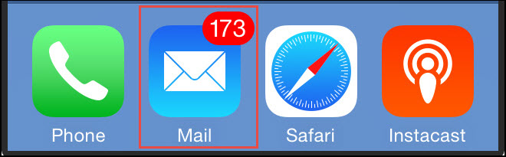

- If you have more than one email account synced in Mail, Select the desired mailbox.
- Click on the email you want to reply to. That email opens to display its contents.
- On the bottom ribbon, click on the Reply button.


- Add a Subject, write your message and tap Send.

- Add an Attachment

Sometimes, it is not enough to reply to an email, an attachment has to be sent along with the email. To add an attachment to the email, follow these simple steps:
- Click on the Arrow button. Select Add Attachment.



- Open the folder from where you need to select the file.
The attachment would be added to your reply. You add more attachments if you want to in that email.

Point to Remember
In iPhone Mail app, the same button opens Reply, Forward and Print. Sometimes this can lead to an erroneous mail while sending a reply to email on iPhone by sender. Users if mistakenly press the Forward button instead of Reply, it will forward that mail. So, it is important to be careful when selecting your option of choice at the time. It sounds like a very basic point, but new users should be extra cautious. With a little practise, these things can be easily mastered.

Smart Method to Reply to a Section of the Mail
In cases where the received email is very long, you might need to respond to a particular part of it. Using iPhone Mail, users can specifically reply to email on iPhone by sender. This is interesting because you can quote a part of the mail in the reply. Reply to a section of the mail as follows:
- Open the email you want to quote.
- Long press on the mail content. Use the selection sliders to mark the desired text and Copy it.
- Tap Reply button. The mail shows only the selected text.
- Write more in the message block if you want.
- Tap Send.
This is very simple technique can improve the quality of your replies. Quoting a part of the mail also makes it easy for the receiver to understand the reply quickly. It is perfect for when the mail consists of a long thread. Also, in a conversation with many people, it is a good feature to specify what context you are replying to.

Tip: This feature is not confined to iPhone Mail. It also works with other email clients like OS X Mail, and iOS Mail app on an iPad.

Conclusion
Nowadays, since many users use iPhone Mail, it has become increasingly important to learn the correct way to reply to an email. This article thoroughly explained how to reply to emails from iPhone Mail the right way. It is crucial to learn the distinction, because the Reply button in iPhone Mail is also used to Forward or Print the mail. The steps to reply smartly by quoting a part of the email are also outlined. This will make iPhone experience even more rewarding for all users. If you have any queries related to replying in iPhone Mail, leave a comment and we will try to resolve it at the soonest.

